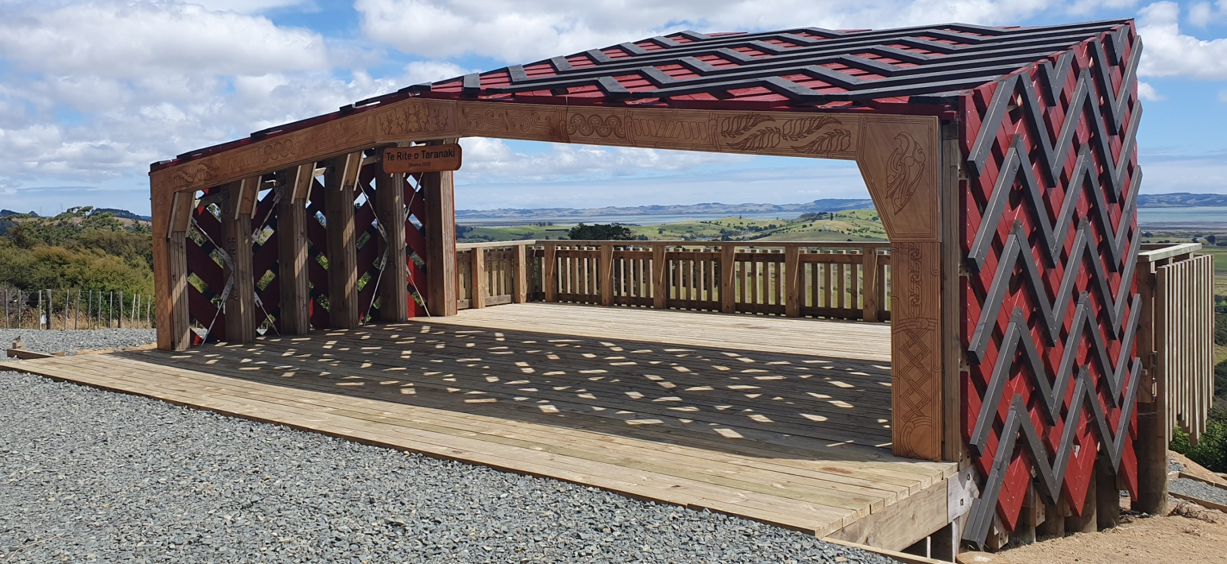
Following a very successful event last year, CUE Haven and Ngati Rango of Ngati Whatua Kaipara, in association with the Auckland Polish Association, POLANZ the Polish-New Zealand Business Association and the Honorary Consul of the Republic of Poland in Auckland have the great pleasure in inviting members of the Polish community and its friends to a Cultural Day - Ngā taonga o tātou tūpuna / Treasures of our ancestors. The Polish community will be hosted by the local Maori iwi - Ngati Rango of Ngati Whatua Kaipara
CULTURAL DAY at CUE Haven Nature Reserve

The Cultural Day will be held at the CUE Haven Nature Reserve, 2704 Kaipara Coast, Araparera and will begin at 9.30am on the 21st of May 2022, with the traditional Maori welcome (powhiri). All attendees are asked to arrive by 9.15 am. The event will enable all to interact with traditional Maori customs and culture.
Morning tea, coffee and biscuits will be provided. A delicious Maori style lunch (hangi) will complement the event. A vegetarian version will be made available for those who let us know a few days in advance.
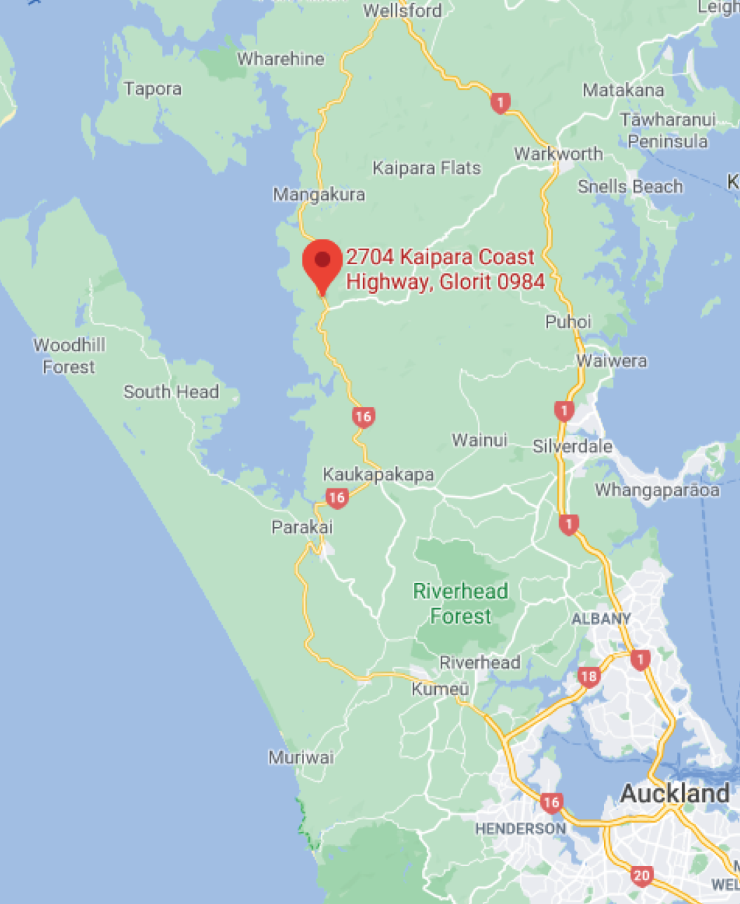
The event will also mark the 150th anniversary of the arrival of the first Polish settlers to the South Island. The day is also dedicated to the suffering people of Ukraine. To mark these two occasions, two commemorative trees will be planted: A Polish 150th Jubilee Tree and a Ukrainian tree.
As the number of attendees is limited to 80 persons, please RSVP by the 7th of May to event coordinator:
Maria Nowak:
Tel: 0274 908 308
Email: maria@greenlitetravel.co.nz
or via Maria's FB messenger
The organisers welcome makers of Polish products like pierogis and cakes to sell their products at the event and donate some part of the profits to support Ukrainian refugees. For more details in this regard please contact Maria via the above listed contacts.

